公司简介

无锡市速达振动电机有限公司是生产振动电机的专业厂家，二十多年来，我们竭诚为客户提供经久耐用的产品和完善的售后服务。
公司主要生产ZDS、LZD 系列振动电机,可配套于振动给料机、振动筛、振动输送机、振动落砂机、振动放矿机、振动干燥机、振动光饰机和料仓振动防闭塞装置等振动机械。广泛应用于矿山、冶金、煤炭、粮食、电力、建材、铸造、化工、医药和轻工食品等行业。

- 公司产品
卧式振动电机 | 立式振动电机
ZDS小功率卧式振动电机 | 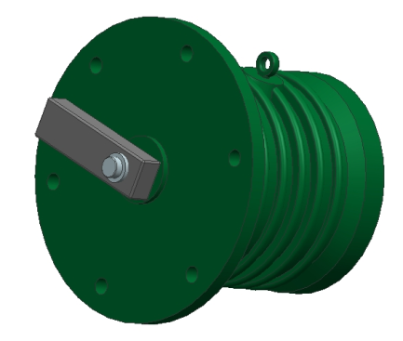  ZDS型立式振动电机
ZDS大功率卧式振动电机 | LZD型立式振动电机
- 产品代号表示
极数
激振力大小
振动电机系列
75
6
LZD

10
6
ZDS
例如：ZDS 10-6 表示：卧式振动电机，激振力10KN 6极
LZD 75-6 表示：立式振动电机，激振力75KN 6极
电机结构示意图

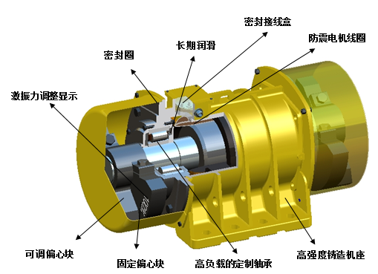

二十多年来,公司不断改进产品设计和制造质量,使产品日臻完善。
  - 在设计上，通过振动电机在各个行业使用中积累的经验，我们的工程师不断的完善产品设计和工艺，使产品的质量更加可靠。特别是在产品的防尘密封上的全新设计，极大的延长了振动电机轴承使用寿命。
  - 在制造过程中,高精度的各类数控加工中心让我们产品部件得到极高的制造精度。
  - 采用全寿命高级润滑脂，使轴承得到可靠的终身润滑。
  - 我们对每一台振动电机的振动特性和电气性能进行了严格测试。

技术特性
- 激振力范围 0~350KN，可以从0-100%调节。
- 机械防护等级: IP55 绝缘等级:B、F 。
- 全封闭结构，可在任何无防爆要求的粉尘条件下工作。
- 润滑：所有振动电机在出厂前都加入足够润滑脂，无需进一步润滑。
- 电压、 频率有特殊设计、制造要求的产品，请联系公司专业技术人员联系。
卧式电机技术参数
2极-2860 rpm 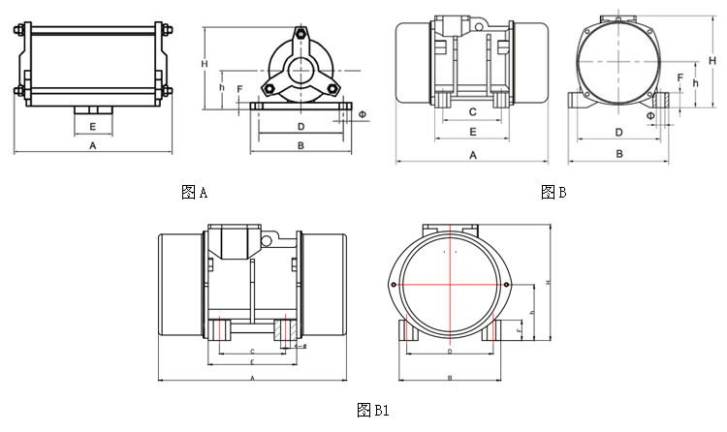
技术数据
型号 | 振次 | 激振力 | 功率 | 电流 | 重量
 | r/min | N | Kw | A | Kg
ZDS-0.6-2 | 2860 | 650 | 0.05 | 0.2 | 4
ZDS-1.5-2 |  | 1500 | 0.1 | 0.3 | 15
ZDS-2-2 |  | 2000 | 0.15 | 0.5 | 16
ZDS-5-2 |  | 5000 | 0.37 | 1.1 | 25
ZDS-10-2 |  | 10000 | 0.75 | 1.96 | 36
ZDS-20-2 |  | 20000 | 1.5 | 3 | 80
ZDS-30-2 |  | 30000 | 2.2 | 4.65 | 100
ZDS-50-2 |  | 50000 | 3.7 | 7.5 | 205

安装尺寸
型号 | 图号 | A | B | H | h | C | D | φ | E | F
 |  | mm | mm | mm | mm | mm | mm | mm | mm | mm
ZDS-0.6-2 | A | 168 | 120 | 97 | 46 | - | 100 | 9 | 40 | 8
ZDS-1.5-2 | B1 | 255 | 160 | 156 | 80 | 40 | 130 | 11 | 70 | 16
ZDS-2-2 | B1 | 255 | 160 | 156 | 80 | 40 | 130 | 11 | 70 | 16
ZDS-5-2 | B1 | 350 | 212 | 215 | 95 | 120 | 150 | 13 | 150 | 30
ZDS-10-2 | B1 | 370 | 243 | 235 | 110 | 130 | 170 | 17 | 174 | 40
ZDS-20-2 | B | 515 | 320 | 276 | 140 | 190 | 260 | 25 | 251 | 45
ZDS-30-2 | B | 590 | 380 | 320 | 146 | 160 | 310 | 32 | 260 | 25
ZDS-50-2 | B | 630 | 470 | 386 | 190 | 250 | 380 | 38 | 330 | 33

卧式电机技术参数
4极-1450 rpm
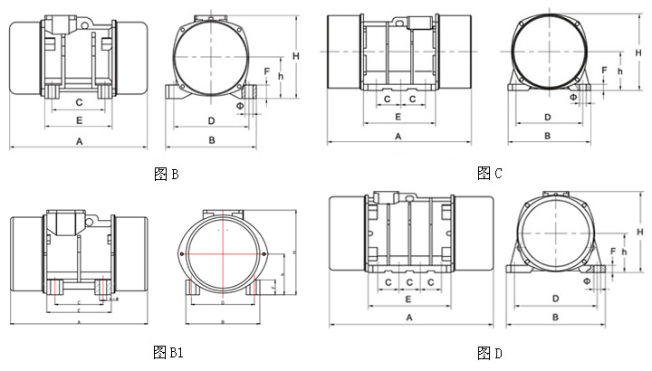
技术数据
型号 | 振次 | 激振力 | 功率 | 电流 | 重量
 | r/min | N | Kw | A | Kg
ZDS-2-4 | 1450 | 2000 | 0.12 | 0.37 | 19
ZDS-2.5-4 |  | 2500 | 0.2 | 0.62 | 24
ZDS-5-4 |  | 5000 | 0.4 | 1.21 | 40
ZDS-8-4 |  | 8000 | 0.55 | 1.5 | 42
ZDS-10-4 |  | 10000 | 0.75 | 2.8 | 54
ZDS-32-4 |  | 10000 | 0.8 | 3 | 60
ZDS-20-4 |  | 20000 | 1.1 | 2.76 | 85
ZDS-30-4 |  | 30000 | 1.5 | 3.3 | 130
ZDS-50-4 |  | 50000 | 2.2 | 6.68 | 180
ZDS-80-4 |  | 80000 | 3.7 | 8.7 | 260
ZDS-100-4 |  | 100000 | 6.3 | 12.5 | 350
ZDS-120-4 |  | 120000 | 8 | 16.6 | 435
ZDS-160-4 |  | 160000 | 10 | 22 | 600

安装尺寸
型号 | 图号 | A | B | H | h | C | D | φ | E | F
 |  | mm | mm | mm | mm | mm | mm | mm | mm | mm
ZDS-2-4 | B1 | 290 | 183 | 185 | 80 | 40 | 130 | 11 | 70 | 16
ZDS-2.5-4 | B1 | 320 | 212 | 215 | 95 | 120 | 150 | 13 | 150 | 30
ZDS-5-4 | B1 | 342 | 243 | 235 | 110 | 130 | 170 | 13 | 160 | 30
ZDS-8-4 | B1 | 400 | 243 | 234 | 110 | 130 | 170 | 17 | 160 | 30
ZDS-10-4 | B | 450 | 270 | 220 | 110 | 160 | 220 | 21 | 210 | 40
ZDS-32-4 | B | 450 | 230 | 219 | 110 | 170 | 180 | 21 | 220 | 40
ZDS-20-4 | B | 515 | 320 | 276 | 140 | 190 | 260 | 25 | 251 | 45
ZDS-30-4 | B | 530 | 350 | 335 | 170 | 180 | 280 | 32 | 251 | 55
ZDS-50-4 | B | 580 | 390 | 340 | 170 | 160 | 310 | 38 | 286 | 30
ZDS-80-4 | C | 730 | 470 | 386 | 190 | 125 | 380 | 38 | 340 | 33
ZDS-100-4 | C | 790 | 520 | 210 | 425 | 140 | 440 | 38 | 410 | 35
ZDS-120-4 | C | 830 | 520 | 210 | 425 | 140 | 440 | 38 | 440 | 40
ZDS-160-4 | D | 930 | 550 | 455 | 220 | 118 | 460 | 38 | 460 | 40
卧式电机技术参数
6极- 960 rpm
技术数据 图B
型号 | 振次 | 激振力 | 功率 | 电流 | 重量
 | r/min | N | Kw | A | Kg
ZDS-2.5-6 | 960 | 2500 | 0.2 | 0.69 | 25
ZDS-5-6 |  | 5000 | 0.4 | 1.18 | 40
ZDS-10-6 |  | 10000 | 0.75 | 2.2 | 75
ZDS-13-6 |  | 13000 | 0.8 | 2.32 | 81
ZDS-18-6 |  | 18000 | 1.1 | 3 | 110
ZDS-20-6 |  | 20000 | 1.5 | 3.5 | 125
ZDS-25-6 |  | 25000 | 1.5 | 3.92 | 145
ZDS-30-6 |  | 30000 | 2.2 | 4.9 | 155
ZDS-36-6 |  | 36000 | 2.2 | 5.52 | 180
ZDS-40-6 |  | 40000 | 3 | 6.5 | 190
ZDS-50-6 |  | 50000 | 3.7 | 9.15 | 260
ZDS-75-6 |  | 75000 | 5.5 | 12.2 | 315
ZDS-100-6 |  | 100000 | 7.5 | 17.9 | 435
ZDS-130-6 |  | 130000 | 9.5 | 21.7 | 620
ZDS-160-6 |  | 160000 | 12 | 24.8 | 680
ZDS-180-6 |  | 180000 | 14 | 31.9 | 720
ZDS-220-6 |  | 220000 | 18 | 35 | 1040
ZDS-250-6 |  | 250000 | 20 | 41 | 1080
ZDS-300-6 |  | 300000 | 22 | 43 | 1100
ZDS-350-6 |  | 350000 | 25 | 50 | 1337
安装尺寸
型号 | 图号 | A | B | H | h | C | D | φ | E | F
 |  | mm | mm | mm | mm | mm | mm | mm | mm | mm
ZDS-2.5-6 | B1 | 350 | 212 | 215 | 95 | 120 | 150 | 13 | 150 | 30
ZDS-5-6 | B1 | 400 | 243 | 235 | 110 | 130 | 170 | 13 | 160 | 40
ZDS-10-6 | B | 455 | 275 | 276 | 140 | 160 | 220 | 21 | 215 | 50
ZDS-13-6 | B | 480 | 305 | 262 | 140 | 165 | 250 | 25 | 220 | 45
ZDS-18-6 | B | 575 | 320 | 276 | 140 | 190 | 260 | 25 | 251 | 45
ZDS-20-6 | B | 615 | 320 | 276 | 140 | 190 | 260 | 25 | 251 | 45
ZDS-25-6 | B | 550 | 350 | 335 | 170 | 180 | 280 | 32 | 251 | 55
ZDS-30-6 | B | 575 | 350 | 335 | 170 | 180 | 280 | 32 | 251 | 55
ZDS-36-6 | B | 650 | 380 | 333 | 170 | 225 | 310 | 32 | 306 | 55
ZDS-40-6 | B | 660 | 380 | 333 | 170 | 225 | 310 | 32 | 306 | 55
ZDS-50-6 | B | 730 | 470 | 386 | 190 | 250 | 380 | 38 | 330 | 45
ZDS-75-6 | C | 846 | 470 | 386 | 190 | 125 | 380 | 38 | 340 | 38
ZDS-100-6 | C | 880 | 470 | 437 | 220 | 140 | 380 | 38 | 410 | 33
ZDS-130-6 | C | 860 | 550 | 501 | 255 | 140 | 460 | 45 | 440 | 40
ZDS-160-6 | D | 1012 | 550 | 501 | 255 | 118 | 460 | 38 | 490 | 33
ZDS-180-6 | D | 1010 | 610 | 525 | 260 | 120 | 520 | 45 | 500 | 33
ZDS-220-6 | D | 1050 | 665 | 575 | 290 | 140 | 560 | 45 | 574 | 45
ZDS-250-6 | D | 1110 | 665 | 575 | 290 | 140 | 560 | 45 | 574 | 45
ZDS-300-6 | D | 1125 | 680 | 645 | 330 | 146 | 570 | 50 | 585 | 50
ZDS-350-6 | D | 1165 | 680 | 645 | 330 | 146 | 570 | 50 | 585 | 50
8极-740 rpm
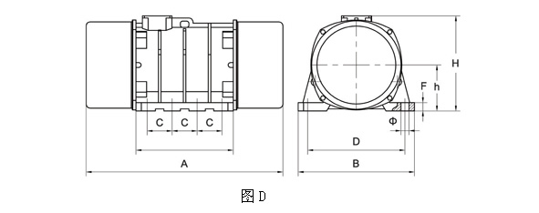
技术数据
型号 | 振次 | 激振力 | 功率 | 电流 | 重量
 | r/min | N | Kw | A | Kg
ZDS-200-8 | 740 | 200000 | 15 | 35 | 1090
ZDS-300-8 |  | 300000 | 22 | 46.7 | 1450
安装尺寸
型号 | 图号 | A | B | H | h | C | D | φ | E | F
 |  | mm | mm | mm | mm | mm | mm | mm | mm | mm
ZDS-200-8 | D | 1090 | 610 | 600 | 305 | 140 | 520 | 45 | 580 | 40
ZDS-300-8 | D | 1325 | 680 | 645 | 330 | 140 | 570 | 50 | 585 | 50

SVM系列-振动电机技术参数
4-6极- 960 转/分

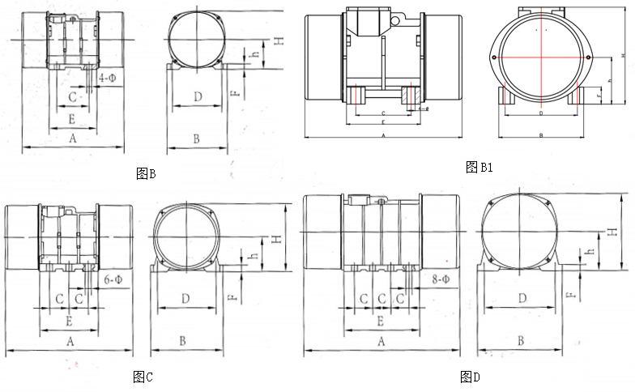

技术数据 三相4极-1450rpm
型号 | 振次 | 激振力 | 功率 | 电流 | 重量
 | r/min | N | Kw | A | Kg
SVM-3-4 | 1450 | 3000 | 0.12 | 0.37 | 21
SVM-5-4 |  | 5000 | 0.25 | 0.78 | 27
SVM-8-4 |  | 8000 | 0.4 | 1.21 | 42
SVM-15-4 |  | 15000 | 0.75 | 2.25 | 54
SVM-20-4 |  | 20000 | 1.1 | 2.76 | 85
SVM-30-4 |  | 30000 | 1.5 | 3.3 | 130
SVM-50-4 |  | 50000 | 2.2 | 6.68 | 180
SVM-80-4 |  | 80000 | 3.7 | 8.7 | 260
SVM-100-4 |  | 100000 | 6.3 | 12.5 | 350
SVM-120-4 |  | 120000 | 8 | 16.6 | 435
SVM-160-4 |  | 160000 | 10 | 22 | 600
SVM-200-4 |  | 200000 | 12 | 22.8 | 650
安装尺寸 三相4极-1450rpm
型号 | 图号 | A | B | H | h | C | D | φ | E | F
 |  | mm | mm | mm | mm | mm | mm | mm | mm | mm
SVM-3-4 | B1 | 322 | 183 | 185 | 80 | 40 | 130 | 11 | 70 | 16
SVM-5-4 | B1 | 350 | 212 | 215 | 95 | 120 | 150 | 13 | 150 | 30
SVM-8-4 | B1 | 370 | 245 | 235 | 110 | 130 | 170 | 17 | 174 | 40
SVM-15-4 | B | 450 | 270 | 220 | 110 | 160 | 220 | 21 | 210 | 42
SVM-20-4 | B | 515 | 320 | 276 | 140 | 190 | 260 | 25 | 251 | 45
SVM-30-4 | B | 505 | 350 | 331 | 170 | 180 | 280 | 32 | 251 | 55
SVM-50-4 | B | 580 | 390 | 340 | 165 | 160 | 310 | 38 | 286 | 30
SVM-80-4 | C | 730 | 470 | 386 | 190 | 125 | 380 | 38 | 340 | 33
SVM-100-4 | C | 790 | 520 | 210 | 425 | 140 | 440 | 38 | 410 | 35
SVM-120-4 | C | 830 | 520 | 210 | 425 | 140 | 440 | 38 | 440 | 40
SVM-160-4 | D | 930 | 550 | 455 | 220 | 118 | 460 | 38 | 460 | 40
SVM-200-4 | D | 930 | 550 | 455 | 220 | 118 | 460 | 38 | 460 | 45
技术数据 三相6极-960rpm
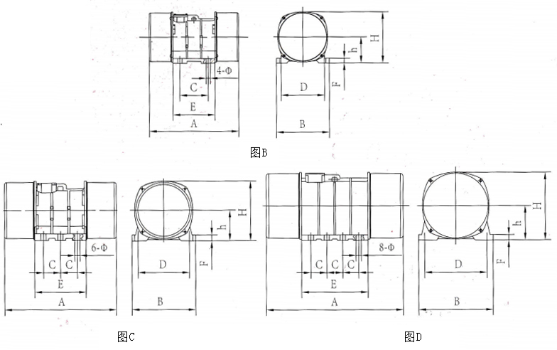
型号 | 振次 | 激振力 | 功率 | 电流 | 重量
 | r/min | N | Kw | A | Kg
SVM-20-6 | 960 | 20000 | 1.1 | 3 | 115
SVM-30-6 |  | 30000 | 1.5 | 3.92 | 155
SVM-40-6 |  | 40000 | 2.2 | 5.52 | 180
SVM-50-6 |  | 50000 | 2.7 | 6.3 | 230
SVM-60-6 |  | 60000 | 3.2 | 7.6 | 250
SVM-80-6 |  | 80000 | 4.5 | 10.3 | 350
SVM-90-6 |  | 90000 | 5.5 | 12.2 | 385
SVM-100-6 |  | 100000 | 6 | 13.4 | 398
SVM-130-6 |  | 130000 | 7 | 15.2 | 460
SVM-150-6 |  | 144000 | 9.5 | 21.7 | 630
SVM-175-6 |  | 176000 | 12 | 24.8 | 750
SVM-195-6 |  | 195000 | 14 | 31.9 | 780
SVM-250-6 |  | 250000 | 18 | 35 | 1000
SVM-350-6 |  | 350000 | 22 | 43 | 1200
安装尺寸 三相6极-960rpm
型号 | 图号 | A | B | H | h | C | D | φ | E | F
 |  | mm | mm | mm | mm | mm | mm | mm | mm | mm
SVM-20-6 | B | 615 | 320 | 276 | 140 | 190 | 260 | 25 | 251 | 45
SVM-30-6 | B | 545 | 350 | 331 | 170 | 180 | 280 | 32 | 251 | 55
SVM-40-6 | B | 660 | 380 | 331 | 170 | 225 | 310 | 32 | 306 | 55
SVM-50-6 | B | 660 | 390 | 376 | 192 | 210 | 320 | 32 | 310 | 35
SVM-60-6 | B | 730 | 390 | 376 | 192 | 210 | 320 | 32 | 310 | 35
SVM-80-6 | B | 770 | 425 | 405 | 205 | 160 | 350 | 32 | 280 | 38
SVM-90-6 | C | 865 | 470 | 440 | 225 | 125 | 380 | 38 | 380 | 43
SVM-100-6 | C | 865 | 470 | 440 | 225 | 125 | 380 | 38 | 380 | 43
SVM-130-6 | C | 870 | 475 | 445 | 220 | 125 | 400 | 38 | 380 | 42
SVM-150-6 | C | 880 | 550 | 501 | 255 | 140 | 460 | 45 | 440 | 40
SVM-175-6 | D | 1012 | 550 | 501 | 255 | 118 | 460 | 38 | 490 | 40
SVM-195-6 | D | 1050 | 610 | 525 | 265 | 120 | 520 | 45 | 500 | 45
SVM-250-6 | D | 1090 | 665 | 575 | 290 | 140 | 560 | 45 | 574 | 45
SVM-350-6 | D | 1110 | 680 | 645 | 330 | 146 | 570 | 50 | 585 | 50
立式电机技术参数
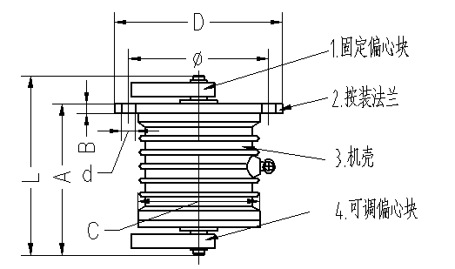
示意图

技术数据

型号 | 振次 | 激振力 | 功率 | 电流 | 重量
 | r/min | N | Kw | A | Kg
ZDS 053-4 | 1450 | 2500 | 0.2 | 0.62 | 24
ZDS 055-4 | 1450 | 5000 | 0.4 | 1.21 | 40
ZDS 0516-4 | 1450 | 1600 | 0.75 | 2.3 | 70
ZDS 0520-4 | 1450 | 20000 | 1.1 | 2.76 | 80
ZDS 0532-4 | 1450 | 32000 | 1.5 | 3.3 | 110
ZDS 0540-4 | 1450 | 40000 | 2.2 | 6.68 | 130
安装尺寸

型号 | 主要尺寸
 | L | A | B | D | C | φ | d
ZDS 053-4 | 321 | 219 | 15 | 215 | 154 | 190 | 6-φ11
ZDS 055-4 | 326 | 295 | 15 | 260 | 174 | 230 | 6-φ11
ZDS 0516-4 | 403 | 331 | 25 | 320 | 204 | 280 | 6-φ13
ZDS 0520-4 | 456 | 343 | 20 | 350 | 250 | 310 | 6-φ17
ZDS 0532-4 | 471 | 367 | 20 | 440 | 310 | 390 | 6-φ17
ZDS 0540-4 | 569 | 322 | 25 | 360 | 286 | 320 | 6-φ21
立式电机技术参数
示意图
A
B
技术数据
型号 | 振次 | 激振力 | 功率 | 电流 | 重量
 | r/min | N | Kw | A | Kg
LZD 75-6 | 960 | 75000 | 5.5 | 12.2 | 372
LZD 135-6 | 960 | 135000 | 9.5 | 21.4 | 620
LZD 160-6 | 960 | 160000 | 12 | 25 | 740
LZD 220-6 | 960 | 220000 | 18 | 39.6 | 1040
安装尺寸
型号 | 图号 | L1 | L2 | L3 | L4 | L5 | D | D1 | D2 | D3 | H | F | L6 | L7 | d | h
 |  | mm | mm | mm | mm | mm | mm | mm | mm | mm | mm | mm | mm | mm | mm | mm
LZD 75-6 | A | 682 | 20 | 25 | 682 | 415 | 530 | 430 | 380 | 480 | 480 | 8-φ21 | 33 | 60 | 60 | 55
LZD 135-6 | B | 825 | 30 | 50 | 480 | 740 | 700 | 580 | 574 | 650 | 650 | 16-φ26 | 50 | 80 | 60 | 55
LZD 160-6 | B | 850 | 30 | 50 | 480 | 770 | 700 | 580 | 574 | 650 | 650 | 16-φ26 | 50 | 80 | 60 | 55
LZD 220-6 | B | - | 30 | 50 | 956 | - | 700 | 580 | 515 | 650 | 650 | 16-φ26 | - | - | - | -
车间生产
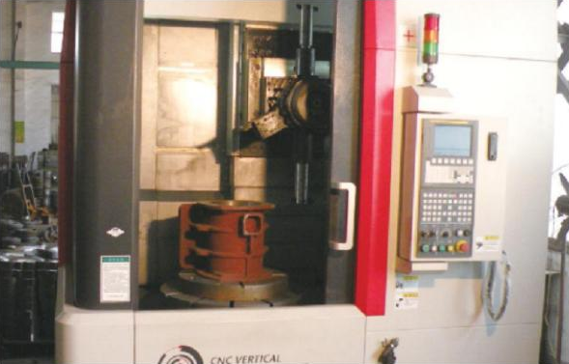 | 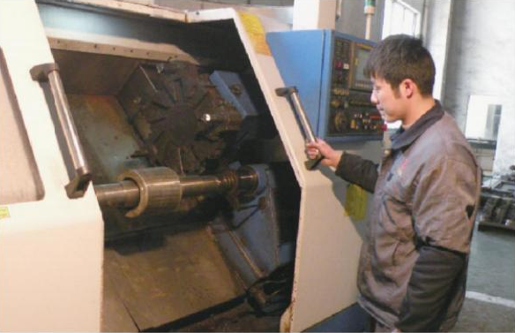
机座加工 | 转子加工
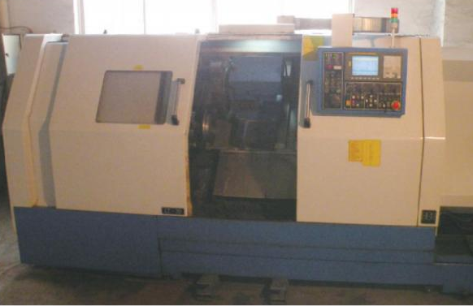 | 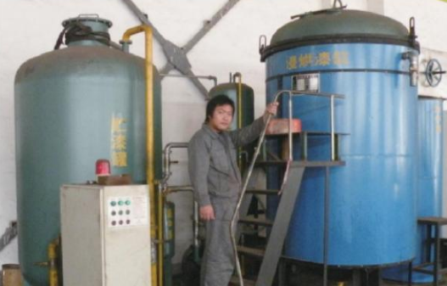
端盖加工 | 真空浸渍
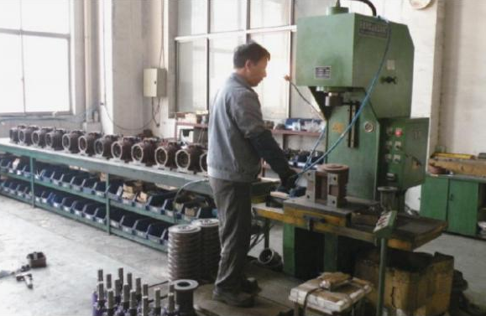 | 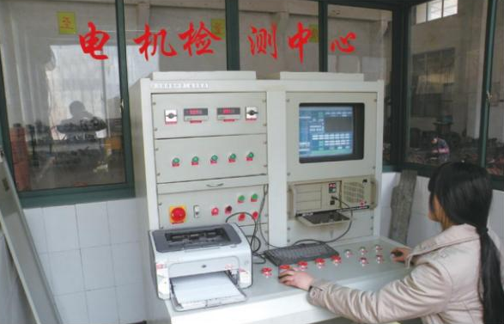
装配线 | 电机电气特性检测
振动电机的选型

振动电机类型选择
转速：1500/3000 转/分
应用：过滤装置
转速：1500/3000 转/分
应用：铸造机械,包装机械,更换炉衬,以及电极生产机械；粮食,煤水泥 混疑土储仓,货舱,型箱,集装箱,车厢,铸造沙箱的振动卸载.
转速：3000 转/分
各种水泥\混疑土预制件的模具,振动台,连接件,支撑件模具,振动站振动成型机
转速：1000/1500 转/分
应用：振动给料,振动输送槽,振动输送管道 ,振动螺旋输送机
转速：1000/1500 转/分
振动筛,分离筛,排水管道,陶瓷筛
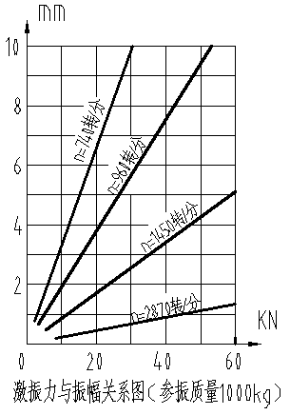
振动电机功率选择
在振动电机选择过程中，振幅的估计至关重要，可以通过以下公式来估计：

$S=\frac{2F}{ϖ^{2}W}$

F: 振动电机的激振力

S：振动电机的双振幅（米 m）
W：振动机械设备的参振重量(千克kg)
（包括振动电机重量，不含物料重量）
$ω$： 电机旋转角频率，与振动电机的极数有关数值如下表所示：
极对数n | $$ω$$
2 | 300
4 | 153
6 | 103
8 | 78
例: 若某振动机械的参振重量为1000Kg(不含振动电机),配有两台ZDS 50-6振动电机,
单台振动电机重量为290Kg,振动产生的振幅为

$S= 2F/ϖ^{2}W$==0.0124m=12.4mm
联系方式
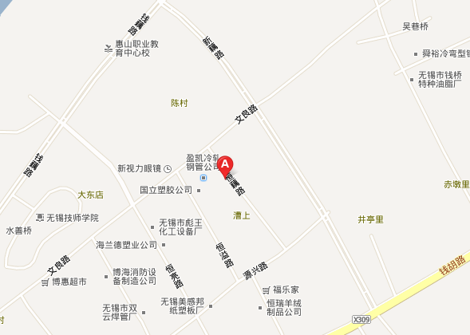
地址：无锡市钱桥镇恒源祥工业园恒藕路9号
电话：0510-85212121 85212854 85259790
传真：0510-85222011

E-mail:
sales@zddj.com
suda@zddj.com

